
Activity 3.1.4 Commercial Roof Systems

Introduction
Larger commercial buildings often employ low-slope (almost flat) roofs. The low slope of the roof allows the roof to be used to support equipment and may also provide an area for human use. Recently “green roofs” on which plants are grown have become popular. In this activity you will discover what accommodations are necessary in order to make a low-slope roof acceptable for human traffic and for use as a green roof.

Equipment
- Engineering notebook
- Internet access
- Pencil
- Printer
- Keystone Library Renovation Preliminary Building(student version).rvt as altered by student

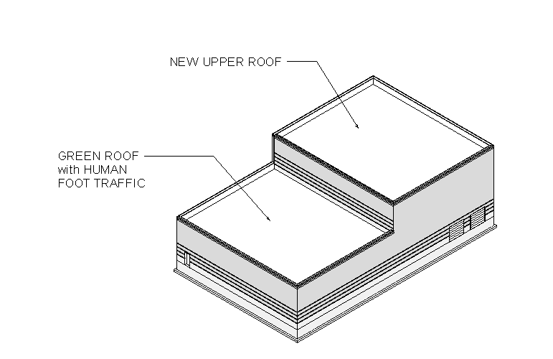

Procedure
- Select a low slope roof treatment for the upper roof of the Keystone project and incorporate your choice into your 3D architectural model. Do not include structural support of the roof at this time.
- Research low-slope roof treatments and walking surfaces that would allow human traffic. In your engineering notebook document three products that could be used as a walking surface on the green roof planned for the lower roof of the Keystone Library. Include sketches or images of each product.

- Research green roofs and document at least two green roof systems that could be used on the lower roof of the Keystone Library. Select a green roof system for use on the Keystone Library Renovation. In your engineering notebook document your selection with a sketch or image of a cross section or of the selected system and label each required layer. Justify your choice.

- Model the green roof system in your 3D architectural software. Do not include structural support of the roof at this time.

- Create a detail (section) view of the green roof in your 3D architectural software.

Conclusion
- Why are flat roofs common on larger commercial buildings?

- Why are the standard pitched roof treatments not acceptable for a low-slope roof?

- Why are the typical low-slope roof surfaces not appropriate when public access is planned?

- What factors are important to consider when designing a green roof?

- What advantages do green roofs provide over standard low-slope roof treatments?

